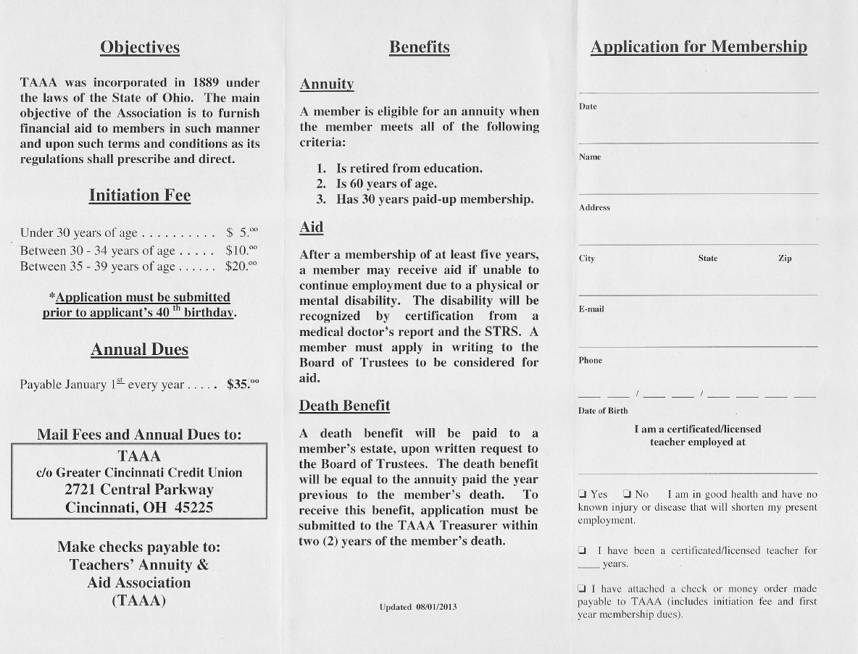

Updated 8/27/2016

TAAA

c/o Greater Cincinnati Credit Union Silverton Branch

7221 Montgomery Road

Cincinnati, OH 45236